Frequently Asked Questions
- When do the new regulations go into effect?
- What are the new immunization dose requirements for school (TK/K-12)?
- What’s DIFFERENT about the new immunization dose requirements for school (TK/K-12)?
- What’s the SAME about the new immunization dose requirements for school (TK/K-12)?
- What’s DIFFERENT about the new immunization requirements for pre-kindergarten (child care or preschool)?
- Where can I find the immunization regulations?
- Do students admitted in previous school years have to meet the new requirements in the 2019-2020 school year?
- Do the new regulations affect the availability of personal beliefs exemptions (PBEs) in California?
- For students admitted to school prior to the 2019-2020 school year, do schools need to transfer information from students’ existing Blue Cards to the new Blue Card?
Medical Exemptions
- For admissions on or after July 1, 2019, what is required for a medical exemption to a required immunization?
- For admissions prior to July 1, 2019, what is required for a medical exemption to a required immunization (per 17 CCR section 6051)?
- Does a medical exemption filed for a child attending before July 1, 2019, need to meet the new requirements?
- May other practitioners, besides licensed physicians (MDs and DOs), provide a medical exemption to a required immunization?
- Has the State of California issued a standardized form for medical exemptions?
- Are licensed physicians required to assist in requests for medical exemptions?
- To meet the chickenpox immunization requirement, may a school accept an immunization record that indicates a "history of chickenpox disease"?
Admission
- What is the definition of admission?
- What is conditional admission?
Students Without Classroom-Based Instruction
- What are the requirements for students entering a home-based private school or independent study program and do not receive classroom-based instruction?
- Do schools still need to record immunization information and report on the immunization status of all students, including students who are exempt from entry requirements due to Senate Bill 277 (Pan, 2015)?
Other Topics
- Are students who are homeless or in foster care subject to the immunization requirements?​

New Pre-kindergarten (Child Care) and School Immunization Requirements
1. When do the new regulations go into effect?
July 1, 2019.
2. What are the new immunization dose requirements for school (TK/K-12)?
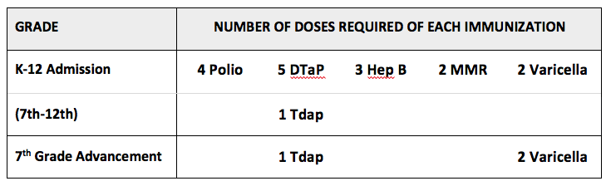
Complete details in 17 CCR section 6025, Table B.
3. What’s DIFFERENT about the new immunization dose requirements for school (TK/K-12)?
Starting in the 2019-2020 school year, school immunization requirements will include:
- 2 (rather than 1) doses of chickenpox vaccine at
♦ TK/Kindergarten entry
♦ 7th grade advancement
♦ TK/K-12 admission or transfer
- 2 MMR doses and 3 Hepatitis B vaccine doses at admission or transfer for most K-12 students.
As these requirements reflect longstanding national recommendations, many children have already met these requirements.
TK/K Admission —
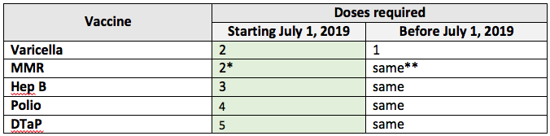
* New requirements also met by 2 doses measles, 2 doses mumps, and 1 dose rubella vaccine.
** Prior requirements also met by 2 doses measles, 1 dose mumps, and 1 dose rubella vaccine.
1st -12th Grade Admission –
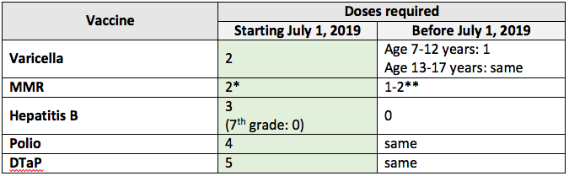
* New requirements also met by 2 doses measles, 2 doses mumps, and 1 dose rubella vaccine.
** Prior requirements also met by:
Age 7-17 years: 1 dose measles, 0 doses mumps, and 1 dose rubella vaccine.
7th grade: 2 doses measles, 0 doses mumps, and 0 doses rubella vaccine.
7th Grade Advancement
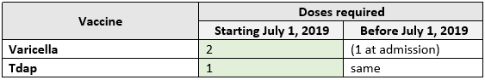
Complete details in 17 CCR section 6025, Table B.
4. What’s the SAME about the new immunization dose requirements for school (TK/K-12)?
Other vaccine dose requirements of 5 doses of DTaP, 4 doses of polio, and 1 dose of Tdap at 7th grade entry remain the same.
Not Changing for TK/K - 12 Admission –
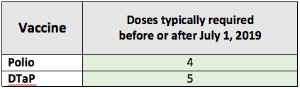
Complete details in 17 CCR section 6025, Table B.
5. What’s DIFFERENT about the new immunization requirements for pre-kindergarten (child care or preschool)?
Starting July 1, 2019, immunization requirements include:
- Chickenpox vaccine is required at age 15 months and older (rather than age 18 months and older).
- Other required vaccine dose requirements remain the same.
- As children age into requirements, parents have 30 days to submit updated records showing the child has met the requirements. For example, when an already admitted child who is up-to-date on shots turns 18 months old, the parents have 30 days from the day the child turns 18 months old to submit records that the child has received the 4th dose of DTaP and 3rd dose of Hep B.
6. Where can I find the immunization regulations?
- Regulations starting July 1, 2019 - http://eziz.org/assets/docs/IMM-1080.pdf
- Regulations through June 30, 2019 - http://eziz.org/assets/docs/IMM-1080_old.pdf
7. Do students admitted in previous school years have to meet the new requirements in the 2019-2020 school year?
If a child is considered an admission at any school at any date on or after July 1, 2019 (including transfer students), the child will need to meet the newer immunization requirements in effect at the time of admission.
If a child is advancing to 7th grade in the fall of 2019 or later, the child must meet the 7th grade requirements in effect at the time of entry into 7th grade (i.e., 1 dose of Tdap, 2 doses of chickenpox vaccine).
If a child has an expiring personal beliefs exemption prior to attending school on or after July 1, 2019, the child will need to meet all current immunization requirements.
8. Do the new regulations affect the availability of personal beliefs exemptions (PBEs) in California?
No. Additional information about PBEs are at www.shotsforschool.org/.
9. For students admitted to school prior to the 2019-2020 school year, do schools need to transfer information from students’ existing Blue Cards to the new Blue Card?
No. Schools may continue to use students’ existing Blue Cards.

Medical Exemptions
10. For admissions on or after July 1, 2019, what is required for a medical exemption to a required immunization?
Starting July 1, 2019, a parent or guardian must submit a signed, written statement from a physician (MD or DO) licensed in California which states:
- The specific nature of the physical condition or medical circumstance of the child for which a licensed physician does not recommend immunization.
- Each specific required vaccine that is being exempted.
- Whether the medical exemption is permanent or temporary.
- If the exemption is temporary, an expiration date no more than 12 calendar months from the date of signing.
11. For admissions prior to July 1, 2019, what is required for a medical exemption to a required immunization (per 17 CCR section 6051)?
A parent or guardian must submit a written statement from a licensed physician (MD or DO) which states:
- That the physical condition or medical circumstances of the child are such that the required immunization(s) is not indicated
- Which vaccines are being exempted
- Whether the medical exemption is permanent or temporary.
- The expiration date, if the exemption is temporary.
12. Does a medical exemption filed for a child attending before July 1, 2019, need to meet the new requirements?
In some cases. A medical exemption filed previously remains valid until the earliest of:
- When the child is next considered to be an admission at a school or pre-kindergarten facility (applies to both temporary and permanent medical exemptions), at which time staff will need to confirm if the previously filed medical exemption meets the newer requirements, or
- The expiration date specified in the medical exemption (applies to temporary medical exemptions)or
- Advancement to 7th grade, for a medical exemption from varicella vaccine or Tdap.
13. May other practitioners, besides licensed physicians (MDs and DOs), provide a medical exemption to a required immunization?
No. Only a licensed Medical Doctor (MD) or Doctor of Osteopathic Medicine (DO) may provide a medical exemption.
In contrast, the other categories of licensed or credentialed practitioners in California previously authorized through 2015 to sign requests for personal beliefs exemptions (e.g., Nurse Practitioner, Physician Assistant, Naturopathic Doctor, or Credentialed School Nurse) may not provide medical exemptions.
14. Has the State of California issued a standardized form for medical exemptions?
No. Any documentation must include the elements described in Question 10.
15. Are licensed physicians required to assist in requests for medical exemptions?
A licensed physician may provide a medical exemption but is not required to do so. Parents or guardians seeking medical exemptions should check with physicians in advance to clarify their policies on medical exemptions.
16. To meet the chickenpox requirement for TK/K-12 admission or for advancement into 7th grade, may a school accept an immunization record that indicates a "history of chickenpox disease"?
No, this is not sufficient documentation to meet school requirements. Medical exemption documentation may be used for a child who had chickenpox disease that was documented by a physician. For more information on medical exemption documentation requirements, see question 10.

Admission
17. What is the definition of admission?
17 CCR section 6000
(a) “Admission” means a pupil's first attendance in a school or pre-kindergarten facility or re-entry after withdrawing from a previous enrollment.
(1) “Unconditional admission” is admission based upon documented receipt of all required immunizations for the pupil's age or grade, in accordance with section 6025, except for those immunizations:
(A) permanently exempted for medical reasons in accordance with section 6051, or
(B) exempted for personal beliefs in accordance with Health and Safety Code section 120335.
(2) “Conditional admission” is provisional admission for a pupil who has received some but not all required immunizations and is not due for any vaccine dose at the time of admission in accordance with sections 6035 and 6050.
18. What is conditional admission?
Children behind on their required immunizations may be admitted conditionally if they are not currently due for any doses or have a temporary medical exemption. See http://www.shotsforschool.org/laws/conditional-admission/ for further information and the conditional admission schedule.

Students Without Classroom-Based Instruction
19. What are the requirements for students entering a home-based private school or independent study program and do not receive classroom-based instruction?
Students entering:
- A home-based private school or
- An independent study program and do not receive classroom-based instruction
are not subject to immunization requirements. Parents or guardians must provide records to the respective schools of any required immunizations received by these students.
20. Do schools still need to record immunization information and report on the immunization status of all students, including students who are exempt from entry requirements due to Senate Bill 277 (Pan, 2015)?
Yes, schools will still need to:
- Record immunizations for all students at entry.
- Report on the immunization status of all students at the checkpoints of child care, kindergarten, and 7th grade.​

Other Topics
21. Are students who are homeless or in foster care subject to the immunization requirements?
Yes. However, a student who is homeless or in foster care, when transferring into a new school, may be admitted immediately if the student arrives without immunization records. Schools should utilize their resources to make sure these students have received all required immunizations as soon as possible.

